What are the criteria for plant biology papers?
- Problem-oriented original research articles (maximum 9000 words)
- Data sharing and data accessibility: have it all on githu!
- Research articles may be submitted that have not been published previously, even as a summary. Concise presentation is required. Although the non-specialist reader should be kept in mind when abstracts, introductions and discussions are written, lengthy review type introductions and speculative discussions should be avoided. Experimental methods should be explained in detail except for standard procedures. Diffuse and repetitive style should be avoided. Illustrations and tables should be limited to the truly essential material.
Plant Biology preferentially publishes short research articles (five typeset pages maximum) that will be reviewed with high priority.
- Arrangement
Research articles
Title page: The first page of each paper should indicate: The title, the authors' names and affiliations, a short title for use as running head, the name, address, e-mail address, phone and fax number of the corresponding author, 3 to 7 keywords, and a one-sentence summary of the key message of the paper.
Abbreviation: List with abbreviations where appropriate.
Abstract: The abstract must be usable as a stand-alone document and must not exceed 250 words. For all papers submitted from 2016 onwards, a structured abstract is required using four bullet points to indicate (1) the research conducted including its rationale, (2) central methods applied, (3) key results, and (4) main conclusions including key points of discussion. It should not contain citations of other papers. For reviews, bullet points do not apply.
The following sections cover the usual contents: Introduction, Materials and Methods, Results, Discussion, Acknowledgements, References (see below), Tables (see below), Figure legends (see below), Illustrations (see below).
In Materials and Methods, Results and Discussion subheadings are possible. If an author chooses to combine sections Results and Discussion, an additional section Conclusions can be added, but this must be brief.
- Introduction is structured without subchapters
- Introduction is two pages max
Potential paragraphs:
- Pollination in general
  - Pollen limitation
  - Self-pollination and self-compatibility
- Self-pollination
  - Pro’s and cons of self compatibility
  - Types of self-compatibility
  - Selfing as an evolutionary dead end
- Montane conditions and pollen limitation
  - Increasing elevation
- What studies are known?
- What is our study aiming to do?
Increased pollination probability hypothesis
Energy-contraint hypothesis
Autogamy reproductive assurance hypothesis
Automatic selection hypothesis

Title
The title will be discussed once we know the results from the visitation data. However the title should include more information about checking the breeding systems along an elevational gradient and should not be so focused on the hand-pollination experiment. At least that’s what I think now, since the project is not about the experimental procedure and more about learning novel information about reproductive strategies in the tropics. So…
Shifts in reproductive strategies of seven plant species along an elevational gradient in Afromontane grasslands?
Changes in breeding systems along an elevational gradient on the grasslands of Mt. Cameroon?
More info about results?

Authors:
Dominik Anýž (1), Ishmeal N. Kobe (1), Štěpán Janeček (1), Sailee Sakhalkar (1), Petra Janečková (1,2), Shedrach B Kongvong (1), Francis E. Luma (1), Carslon Bawe (3), Fernando P. Gaona (1,4), Petr Chlup (1), Robert Tropek (1,4)

Affiliations:
(1) Department of Ecology, Charles University, Prague (2) Faculty of Science, university of South Bohemia, České Budějovice (3) Faculty of Science, University of Buea, Cameroon (4) Institute of Entomology, Biology Centre, Czech Academy of Science, České Budějovice

Keywords

Abstarct
No idea yet

Introduction
Reproductive success in angiosperms often depends on the efficient transfer of pollen by animal pollinators, a strategy that supports approximately 85% of flowering plant diversity (Ollerton et al., 2011). However, in environments where pollinators are scarce, such as high-altitude ecosystems, plants can experience pollen limitation—a reduction in reproductive success due to insufficient pollen supply (Knight et al., 2005; Torres-Díaz et al., 2011).To overcome this barrier, plants employ various strategies to ensure reproduction, including shifts in breeding systems, which can have profound ecological and evolutionary implications.
One of the most significant shifts in breeding systems involves the transition from self-incompatibility to self-compatibility. Many plants rely exclusively on genetically distinct pollen for fertilization (termed outcrossing pollination, or xenogamy) (Ferrer and Good-Avila, 2007; Wright et al., 2013). However, when pollinator visitation is unreliable, self-compatibility can provide reproductive assurance by enabling self-fertilization (selfing)(Takebayashi and Morrell, 2001). While this shift can be advantageous in pollinator-limited environments, it also carries evolutionary trade-offs, such as inbreeding depression and reduced genetic diversity, which may influence long-term population viability (Barrett et al., 2014; Schemske and Lande, 1985).
High-elevation habitats present a particularly challenging environment for plant reproduction, where pollinator abundance and activity decline due to low temperatures, strong winds, and reduced floral resources (Arroyo et al., 1985; Totland, 1997). In response, plants have evolved diverse reproductive strategies to mitigate pollen limitation. Some species extend floral longevity, increasing the window for pollination, while others bypass sexual reproduction entirely and rely on clonal propagation (Torres-Díaz et al., 2011; Trunschke & Stöcklin, 2017). However, an intermediate strategy that maintains sexual reproduction while reducing dependence on pollinators is self-fertilization. The “autogamy reproductive assurance hypothesis” suggests that selfing evolves as an adaptive response to pollinator scarcity, ensuring seed set when pollen transfer is unreliable (Schoen et al., 1996). Rather than being mutually exclusive, these strategies can co-occur within plant communities, shaping reproductive dynamics in high-altitude environments.
Despite these theoretical frameworks, empirical evidence regarding the prevalence and drivers of selfing along elevational gradients remains mixed. While some studies have documented increased selfing in high-altitude populations of already self-compatible species (Etcheverry et al., 2008; Seguí et al., 2018), others have found no such trend (Gugerli, 1998; Wirth et al., 2010). This gap hinders our understanding of how plants adapt to high-altitude environments and the role of selfing as a reproductive strategy.
Here, we examine the breeding systems of seven plant species in montane grasslands along an elevational gradient on Mount Cameroon, Central Africa’s highest peak. Mount Cameroon, with its sharp elevational range (0–4,095 m a.s.l.), provides an ideal natural laboratory to study plant adaptation in tropical montane ecosystems. We hypothesize that (1) reproductive output decreases with elevation due to harsher environmental conditions; (2) pollen limitation intensifies at higher altitudes; and (3) autonomous self-pollination increases with elevation, reflecting an adaptive response to pollinator scarcity. By addressing these hypotheses, this study aims to provide novel insights into the interplay between reproductive strategies and environmental gradients in a poorly studied montane biome.

Methodology / Materials and methods
Plant biology has “Materials and methods separated into parts. What are the parts which I would like to emphasize?
- Study site and species
- Hand-pollination experiment
- Visitation data
- Statistical analysis

Study site and species
The study was conducted on Mount Cameroon, above the timberline in montane grasslands at four elevations: 2,300 m, 2,800 m, 3,500 m, and 4,000 m a.s.l. Data collection was carried out over three years due to logistical constraints caused by the COVID-19 pandemic. In 2019, surveys were conducted at 2,800 m (Hut 2: 4°11'38"N, 9°11'51"E) and 3,500 m (Wevondi Cave: 4°12'14"N, 9°11'9"E). In 2020, sampling at 4,000 m (Hut 3: 4°12'33"N, 9°10'48"E) was conducted with the assistance of local collaborators led by co-author Kobe Ishmeal. Finally, in 2021, the lowest elevation, 2,300 m (Mann’s Spring: 4°8'40"N, 9°7'14"E), was surveyed when travel restrictions were eased.
In 2019, all flowering zoogamous plant species present within the studied elevations were identified. From these, seven plant species were selected based on the following criteria:
i. Occurrence in at least two of the studied elevations.
ii. Adequate specimen abundance within individual elevations.
iii. Suitability for hand-pollination experiments, including large and robust flowers or inflorescences, sufficient flower quantity per plant, and accessibility of pollen and stigmas.
The following plant species were chosen for the hand-pollination experiment: Clematis simensis (Ranunculaceae), Crepis hypochoeridea (Asteraceae), Geranium arabicum (Geraniaceae), Hypericum revolutum (Hypericaceae), Lactuca inermis (Asteraceae), Senecio burtonii (Asteraceae) and Senecio purpureus (Asteraceae).

Hand-pollination experiment
To determine the breeding systems of selected plant species, hand-pollination experiments were carried out on individual flowers and seed-sets produced by the flowers were used to assess reproduction efficiency. Within a given elevation, unopened buds of the experimental species were covered with nylon mesh bags of appropriate sizes to prevent pre-experimental pollination. One of four treatments was to be carried out on experimental flowers (Fig. 1):
- Autogamy (A): Flowers were bagged to prevent external pollen transfer.
- Geitonogamy (G): Flowers were hand-pollinated with pollen from another flower on the same individual.
- Outcrossing (O): Flowers were hand-pollinated with pollen from a different individual located at least 50 m away.
- Control (C ): Flowers were left exposed to natural pollination.
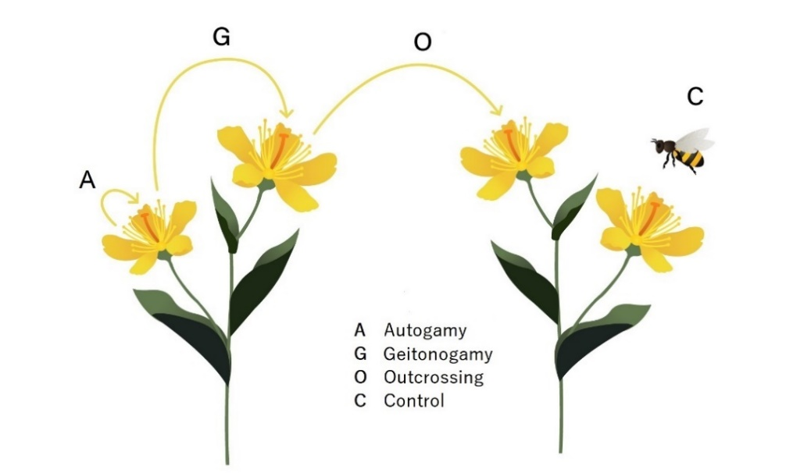
Figure 1. The four experimental treatments illustrating pollen transfer (yellow arrows) on the studied plant species. Illustrator: Barbora Drozdová
For every three buds bagged on a plant, one was left uncovered and labeled as a control flower. Untreated flowers were also left to serve as pollen sources for geitonogamy. Each plant species was tested with at least 40 replicates per elevation (10 per treatment) on at least 10 distinct plant individuals, whenever possible. Every experimental plant individual was labelled with a plant ID, which consisted of the elevation in which the individual occurred, the species of the individual and a unique number specific to one individual for a given species per elevation.
Experimental flowers were observed to determine optimal timing for pollination based on stigma receptivity and pollen viability. When a flower became receptive, it was unbagged, the assigned treatment was performed, and the flower was re-bagged. Pollen transfer was conducted by brushing pollen from a conspecific flower onto the stigma and verifying success with a magnifying glass. Control flowers were bagged after flowering to preserve seeds.
For some Asteraceae species, where inflorescences flower over ~1 week, pollination was repeated daily until all florets were treated. Species with limited simultaneous flower availability (e.g., Lactuca inermis and Geranium arabicum) were subjected to fewer treatments, prioritizing autogamy + control or outcrossing + control
Approximately 30–40 days after the experiments, when the flowers had fruited, all mesh bags were collected. Each bag containing a fruit was cut off, placed in a labeled paper bag, and dried using silica gel. Labels included the elevation, plant species, plant number, and applied treatment. The fruits were subsequently transported to Czechia, where they were sorted by species.
For each plant species, a reference chart was created from ~10 bags (each containing one flower/inflorescence) to distinguish between fully developed and undeveloped seeds. Seeds were counted using a stereomicroscope in a paper tray, except for Hypericum revolutum, whose seeds, due to their small size and pod structure, were counted using a counting grid.

Visitation data
It it not yet clear how much of use will this data be, so this part is just a
Alongside the hand-pollination experiment, our research group was simultaniously conducting a complementary study on pollination networks along the same elevational gradient. From this broader dataset, we extracted visitation data relevant to our study species to assess their interactions with pollinators and potential influences on reproductive success.
To document pollinator visitation, six 100 m × 5 m transects were established at each elevation, where all flowering plant species were identified. Each species was monitored using a VIVOTEK IB8367T CCTV camera with IR night vision for 24-hour periods, repeated seven times per species across the transects, where it was present (for more information on the methodology see Mertens et al., 2018, 2020; Klomberg et al., 2019).
All visitors were identified into species level and only visitors belonging into one of eight predefined functional groups were used in further analysis: Bee, Beetle, Bird, Butterfly, Hoverfly, Other Fly, Moth, Wasp.

Statistical analysis
To analyze changes in seed production by elevation, four indexes were calculated: control, pollen limitation, autogamy and geitonogamy. For the control index, the seedsets of individual flowers treated with the control treatment were used as indexes. For the remaining indexes, the number of seeds produced by outcrossing treatment were considered to be the maximum number of seeds capable of being produced by a given plant in a given elevation. The pollen limitation index was calculated as PL = 1 – C / O, where a value of 0 signifies no pollen limitation and a value of 1 signifies complete pollen limitation. If the index returned a negative number, the value was converted to 0, since any value below zero means that the plants produced more seeds with the control treatment than the outcrossing treatment, thus making them not pollen limited. Both the autogamy and geitonogamy index were calculated as A/O and G/O, respectively. The autogamy and geitonogamy indexes contain continuous variables, so the data was transformed: “index” was multiplied by 100 to be able to be analyzed.
To answer the question of whether elevation had any effect on the indexes, packcage glmmTMB in R studio was used to fit a generalized linear mixed model for each index. For each index, the model which I fit for all the indexes was as follows: “index” was the dependant variable, “elevation” was fit as the predictor. Two random effects were added: “species” which was only the name of the species, and “plant.id”, a crossed effect consisting of the elevation, species and the specific plant number on which the treatments were carried out in a given elevation. This was to take care of the pseudoreplications of having multiple seedsets from one plant individual in some cases.
Index ~ elevation + (1|species) + (1|plant.id)
For the control index, the best fit for the data was a zero-inflated negative binomial distribution. For pollen limitation, since it contained values from 0 to 1, the ordbeta family was used, which is capable of carrying out a beta regression containing significant 0’s and 1’s are present. For autogamy the best fitting model was a zero inflated poisson. For geitonogamy, the best fitting model was a zero inflated poisson. The DHARMa package was used in all cases to assess the goodness of fit for all the models.
To analyze the effect of individual visitation frequencies in given elevation on the hand-pollination indices, we used …

Results
The analysis shows that plants in elevation 2800 had the highest capability of producing seeds when left to be pollinated by visitors (P = 0.00165). Plants from elevations 2300 and 3500 produced similar amount of seeds (both lower than 2800) and plant in 4000 produced significantly fewer seeds than any of the lower elevations (P = 0.00109). This was further evidenced by the zero-inflation model, which showed that plants in elevation 4000 produced more zero’s than any other elevation (P < 0.0001). Seedsets of individual plants in various elevatios is show in Fig. 2
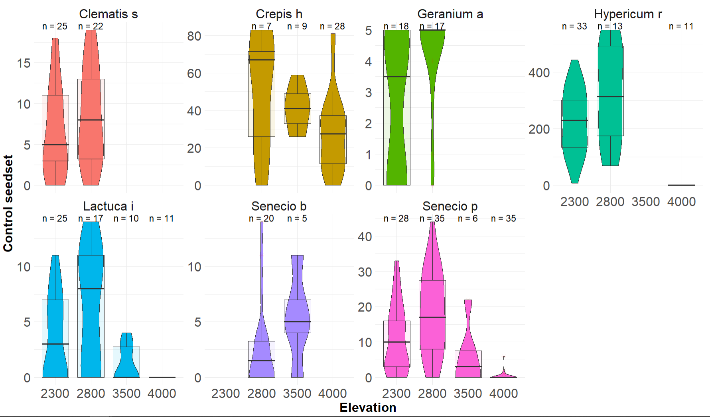
Figure 2. Control index values for seven experimental plant species across four elevations. Each subplot represents a different species, with control index data shown for the elevations where the species was studied. The number of observations per elevation (n) is indicated above each violin plot.
The only trend in pollen limitation was found in elevation 4000, which was significantly more pollen limited than the other elevations (P < 0.0001).
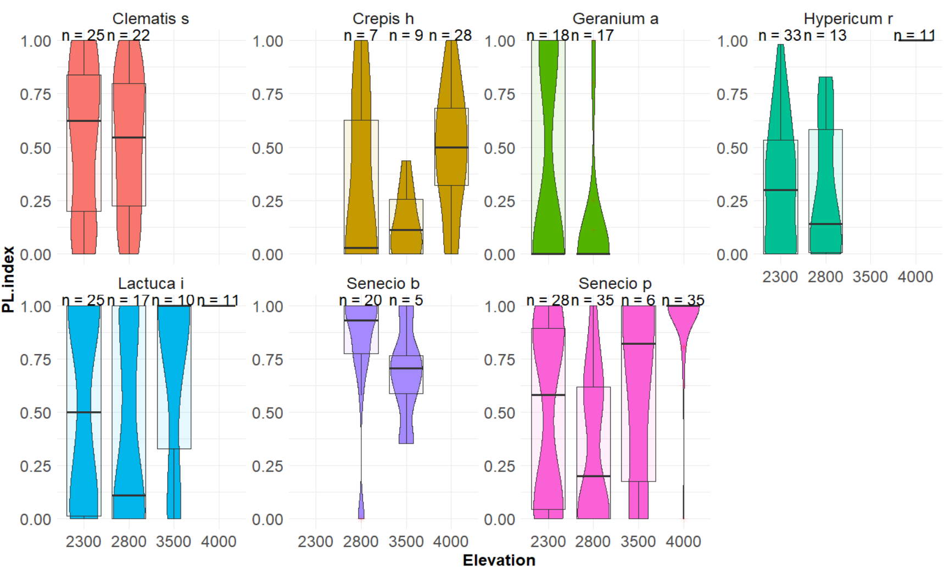
Figure 2. Pollen limitation (PL) index values for seven experimental plant species across four elevations. Each subplot represents a different species, with PL index data shown for the elevations where the species was studied. The number of observations per elevation (n) is indicated above each violin plot.
Autogamy was borderline significantly lower in elevation 4000 (P = 0.05861) that the intercept (elevation 2300), so there is a possibility that the highest elevation produced less seeds when plant were left to self pollinate than the lower elevation. The zero inflation model shows that elevation 4000 was most probable to produce zero’s (P = 0.00186)
An opposite trend was observed in geitonogamy, where plants were observed to produce more seeds through geitonogamy in elevation 4000 when compared with elevation 2300 (p = 0.159), however we did have geitonogamy treatment from only two species in 4000 (Senecio purpureus and Crepis hypochoeridea) and so these results must be interpreted carefully.

For the graphs, Saillee’s suggestions:
- Pictures of species in individual graphs
- When possible, add overall graph (it will not be possible only for the control index, since the variations in seeds produced are huge)
- Play around with the median. Violin plots are ok, maybe try just a dot for the median without an overlaying boxplot?
- Lighter colors
- Inkscapped
- 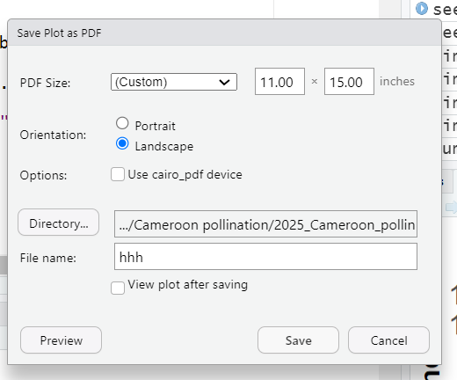

Discussion

Conclusion

References
Arroyo, M.T.K., Armesto, J.J., Primack, R.B., 1985. Community studies in pollination ecology in the high temperate Andes of central Chile II. effect of temperature on visitation rates and pollination possibilities. Plant Syst. Evol. 149, 187–203. https://doi.org/10.1007/BF00983305
Barrett, S.C.H., Arunkumar, R., Wright, S.I., 2014. The demography and population genomics of evolutionary transitions to self-fertilization in plants. Philos. Trans. R. Soc. B Biol. Sci. 369. https://doi.org/10.1098/rstb.2013.0344
Etcheverry, A.V., Alemán, M.M., Fleming, T.F., 2008. Flower morphology, pollination biology and mating system of the complex flower of Vigna caracalla (Fabaceae: Papilionoideae). Ann. Bot. 102, 305–316. https://doi.org/10.1093/aob/mcn106
Ferrer, M.M., Good-Avila, S.V., 2007. Macrophylogenetic analyses of the gain and loss of self-incompatibility in the Asteraceae. New Phytol. 173, 401–414. https://doi.org/10.1111/j.1469-8137.2006.01905.x
Gugerli, F., 1998. Effect of elevation on sexual reproduction in alpine populations of Saxifraga oppositifolia (Saxifragaceae). Oecologia 114, 60–66. https://doi.org/10.1007/s004420050420
Knight, T.M., Steets, J.A., Vamosi, J.C., Mazer, S.J., Burd, M., Campbell, D.R., Dudash, M.R., Johnston, M.O., Mitchell, R.J., Ashman, T.L., 2005. Pollen limitation of plant reproduction: Pattern and process. Annu. Rev. Ecol. Evol. Syst. 36, 467–497. https://doi.org/10.1146/annurev.ecolsys.36.102403.115320
Ollerton, J., Winfree, R., Tarrant, S., 2011. How many flowering plants are pollinated by animals? Oikos 120, 321–326. https://doi.org/10.1111/j.1600-0706.2010.18644.x
Schemske, D.W., Lande, R., 1985. The evolution of self-fertilization and inbreeding depression in plants. II. Empirical observations. Evolution 39, 41–52. https://doi.org/10.1111/j.1558-5646.1985.tb04078.x
Seguí, J., Lázaro, A., Traveset, A., Salgado-Luarte, C., Gianoli, E., 2018. Phenotypic and reproductive responses of an Andean violet to environmental variation across an elevational gradient. Alp. Bot. 128, 59–69. https://doi.org/10.1007/s00035-017-0195-9
Takebayashi, N., Morrell, P.L., 2001. Is self-fertilization an evolutionary dead end? Revisiting an old hypothesis with genetic theories and a macroevolutionary approach. Am. J. Bot. 88, 1143–1150. https://doi.org/10.2307/3558325
Torres-Díaz, C., Gómez-González, S., Stotz, G.C., Torres-Morales, P., Paredes, B., Pérez-Millaqueo, M., Gianoli, E., 2011. Extremely long-lived stigmas allow extended cross-pollination opportunities in a high andean plant. PLoS ONE 6, 1–8. https://doi.org/10.1371/journal.pone.0019497
Totland, Ø., 1997. Effects of flowering time and temperature on growth and reproduction in Leontodon autumnalis var. taraxaci, a late-flowering alpine plant. Arct. Alp. Res. 29, 285–290. https://doi.org/10.2307/1552142
Wirth, L.R., Graf, R., Gugerli, F., Landergott, U., Holderegger, R., 2010. Lower selfing rate at higher altitudes in the alpine plant Eritrichium nanum (Boraginaceae). Am. J. Bot. 97, 899–901. https://doi.org/10.3732/ajb.0900297
Wright, S.I., Kalisz, S., Slotte, T., 2013. Evolutionary consequences of self-fertilization in plants. Proc. R. Soc. B Biol. Sci. 280. https://doi.org/10.1098/rspb.2013.0133

